Find Digits
Platform: HackerRank
Language: C
Module 4, Question 2

Problem Link
https://www.hackerrank.com/challenges/find-digits/problem

Problem Statement
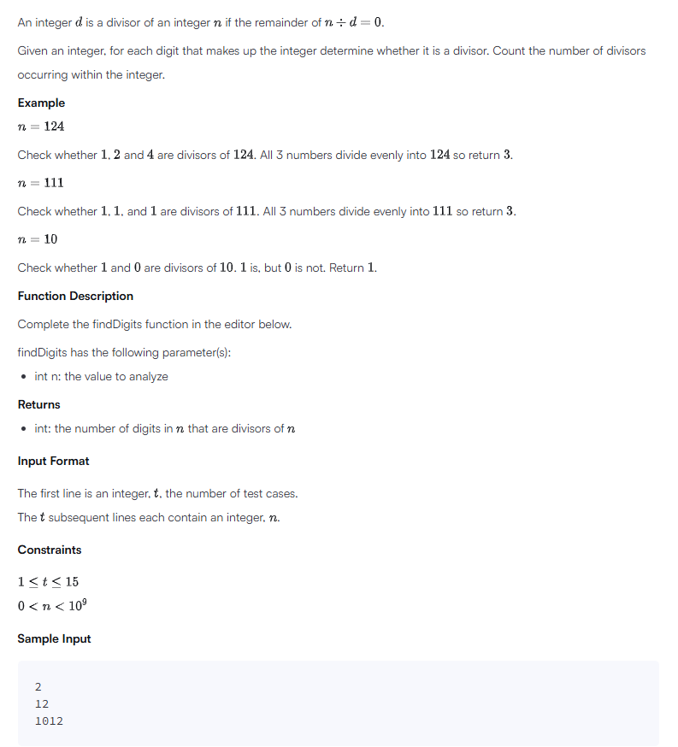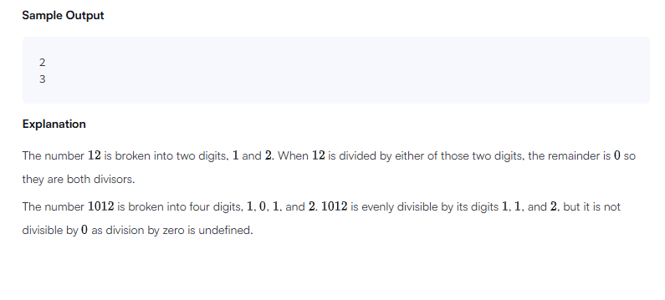

C Code
#include <stdio.h>

int main() {
int t;
scanf("%d", &t);

while (t--) {
int n;
scanf("%d", &n);

int temp = n, count = 0;
while (temp > 0) {
int d = temp % 10;
if (d != 0 && n % d == 0) // skip 0 to avoid dividing by zero
count++;
temp /= 10;
}
printf("%d\n", count);
}
return 0;
}

Screenshot of Successful Submission



